Policy For Managing Aesthetic Complications and Delayed onset Nodules
Beauty skin Deep Cosmetics Ltd

2016
Authored by: alisa Stevenson

Beauty Skin Deep Cosmetics Ltd
Resuscitation Policy
Introduction
The contents of this policy are to guide the practice of all practitioners working with dermal fillers and injecting prescription dermal fillers following these guidelines. For the purpose of these guidelines the definition of a delayed onset nodule is a visible or palpable unintended mass, which occurs at or close to the injection site of dermal filler. Lumps, masses, nodules, regions reactions, biofilms, sterile abscesses and granulomas are terms used to describe a delayed onset nodule (Aesthetic complication Expert Group 2015).
2 Purpose
The purpose of the policy is to provide direction and guidance for the planning and implementation of a high-quality and robust system of managing and treating complications as a consequence of injecting dermal fillers, as part of the risk assessment management for beauty skin deep cosmetics Ltd. Foreign body granulomas are rare with an estimated incidence of between 0.01% and 1% . They can occur with all injectable dermal fillers and usually appear after a latent period of several months to years after treatment. One study reported the incidence of granulomatous foreign body reactions with bovine collagen at 1.3 %. 5. The aim of the policy is to reduce incidence, implement treatment pathways and prevent any potential complications from injectable fillers.
Policy Statement.
It is the policy of this Beauty Skin Deep Cosmetics Ltd
that in the course of their duties staff will familiarize them self with the policy for managing complications for inject able fillers, also screen for those most at risk of developing delayed onset nodules DON and follow correct aseptic technique when carrying out the procedure in line with beauty skin deep cosmetics Ltd policy and procedures.
4 Duties & Responsibilities Companies who provide inject able fillers to clients have an obligation to provide safe and effective staff who are appropriately trained in managing complications from inject able fillers. There practices should practice in line with safe infection control policies and procedures. Also follow the Aesthetic complication Expert Group guidance on managing complications.
4.1 Clinical Directors Responsible within their delegated portfolio for ensuring that appropriate arrangements are in place for implementing this policy in all clinics.
4.2 Line Manager Responsibilities Familiarise themselves and comply with the requirements laid down in this policy and training matrix for those carrying out inject able filler treatments.
Ensure that members of their staff are released for, and receive appropriate training for managing complications, keeping up to date with CPD requirements, infection control and prescribing up dates.
The minimum training requirements are outlined in the mandatory training statement.
To develop an action plan to manage staff who repeatedly fail to attend training.
Ensure that all staff know how to report incidents with beauty skin deep cosmetics policy.

4.3 Standard of Training
Relevant staff must achieve a minimum standard of ability to be considered competent. Reducing risk of delayed on set nodules:
- Patient selection avid those on drug which immunomodulatory drugs,
- Selection of correct product for correct area.
- Use of dermal filler with safety documentation.
- Use of Dermal filler from aesthetic pharmacy which has been appropriately transported and stored.
- Administration of dermal fillers using aseptic technique.
- Thorough cleansing disinfection with 2% chlorhexidine gluconate in 70% alcohol, full removal of skin debris, thorough hand sanitation, wearing sterile gloves ACE group guidance on management of acute skin infections.
4.4 Management of Delayed Onset Nodules This will involve initial assessment of the client including the impact it has on the client. Is it palpable within the skin but not visible and they may be best left alone with watchful eye. Explain risk versus benefits if treatment is necessary or intervention, photography and good record keeping.
A lump presenting at the time or within hours of treatment is likely to be product misplacement, adjuvant anaesthetic or oedema. Massage by the practitioner and patient should be the immediate response to over correction o r product placed too superficially. Vigorous massage is of benefit and will help disperse the product.
Lumps 3-14 days : redness, heat, tenderness, swelling along side features of acte inflammation are likely to be due to infection and should b dealt with according to flow chart one.
Small papules or nodules in the early stages: may be amenable to aspiration with 21 G needles or by superficial incision and can be treated with hyaluronidase see flow chart 2. Should be used with caution if infection is also suspected as this may lead to the inection spreading further along the tissue plane.
4.7 Audit Form All resuscitation attempts must be clearly documented in the clients consent / medical record. Incident form/ report must be completed in accordance with the company incident reporting system.
4.8 Adverse Incidents Significant adverse incidents relating to cardiac arrest/resuscitation are reported using the company incident reporting system. An action plan including communication of lessons learned and any remedial action is then formulated.
4.9 Risk Assessments All clinic areas should ensure that the appropriate resuscitation equipment is available. The service manager should undertake a risk assessment to establish the level of equipment required for their area, and the skill level required to operate this where appropriate if necessary.
5.Do Not Attempt Cardiopulmonary Resuscitation (DNACPR) which fully comply with the guidance issued by the BMA / RCN / Resuscitation Council (UK) (2002) and the recommended standards issued in the Joint Statement from the Royal College of Anaesthetists, the Royal College of 13 Physicians, the Intensive Care Society and the Resuscitation Council (UK) standards for clinical practice and training that state: It is essential to identify (a) client for whom cardiopulmonary arrest is an anticipated terminal event and in whom cardiopulmonary resuscitation (CPR) is inappropriate; and (b) clients who do not want to be treated with CPR; All clinics should ensure that there is a clear and explicit resuscitation plan for all clients.
Where there is no resuscitation plan and the wishes of the clients are unknown, resuscitation should be initiated if cardiopulmonary arrest occurs. However, a decision not to attempt resuscitation may be appropriate when; the clients condition indicates that CPR is unlikely to be successful, or CPR is not in accord with an applicable Advanced Decision or successful CPR is likely to be followed by a length and quality of life that is not in the best interests of the clients. The overall responsibility for decision about DNACPR orders rests with the consultant in charge of the clients care. Adherence to the Mental Capacity Act (2005) Discussion when to stop should be made when the emergency services have arrived at the scene. (available online at www.opsi.gov.uk/ACTS/acts2005/ukpga_20050009_en_1) which came in to force on 1st April 2007.
5.1 Resuscitation Equipment, Replenishment and cleaning the resuscitation trolleys/grab bags will be subject to audit performed by the qualified nurse. The resuscitation trolleys should be stocked in accordance with the standardised list issued by the clinic nurse manager. Disposable items should be replenished at the earliest opportunity from the central storage areas. Non-disposable items should be decontaminated / cleaned in accordance with both the manufacturers’ policy and the company-wide infection control policy and re-instated to the trolley as soon as is practical. All discrepancies must be reported to the senior member of staff on duty, which has a responsibility to ensure that the resuscitation box is fully stocked as soon as possible and at the very latest within twenty four hours. Action taken to replace missing items must be recorded in the resuscitation box. Completed cardiac arrest box/emergency equipment checklists, clearly identifying the department and date. To include pocket mask, and epinephrine for Anaphylaxis.
5.2 Cross Infection Whilst the risk of infection transmission from patient to rescuer during direct mouth-to mouth resuscitation is extremely rare, isolated cases have been reported. It is therefore, advisable that mouth to mouth ventilation is avoided in the following circumstances:
All clients who are known to have or suspected of having an infectious disease.
All clients where the medical history is unknown.
New clients or change in their medical history.
All clinical areas have rapid access to bag, valve and mask devices or pocket masks to eliminate the need for mouth-to-mouth ventilation.
However, in situations where airway protective devices are not immediately available, start chest compressions whilst awaiting an airway device. If there are no contraindications consider giving mouth-tomouth ventilations.
5.3 Anaphylaxis The management of suspected anaphylaxis by aesthetic nurse in clinic should be conducted in accordance with the Resuscitation Council (UK) Guidelines 2008 (Appendix I )
5.4 Automated External Defibrillators Automated external defibrillators (AEDs) are very effective at guiding the operator through the process of administering a shock. They have become widely available. Whilst it is highly desirable that those who may be called upon to use an AED should be trained in its use, and keep their skills up to date, circumstances can dictate that no trained operator (or a trained operator whose certificate has expired) is present at the site of an emergency. In these exceptional circumstances the company are guided by the Resuscitation Council (UK) and place no restrictions on the use of the AED by train NHS emergency service workers. Where there is no AED on the clinic site, 999 must be called and stated to emergency service operator adult cardiac arrest AED required. The same principle applies to those whose period of qualification has expired. (Statement on the training required to use an automated external defibrillator – Resuscitation Council UK April 2009 revised November 2009).
Equality and Diversity Statement
Beauty Skin Deep Cosmetics Ltd is committed to ensuring that as far as is reasonably practicable, delivery of services to the public and the approach to employees reflects their individual needs and does not discriminate against individuals or groups on any grounds. Appendix O 22 Process for monitoring compliance with, and the effectiveness of this Policy The clinic manager will attend cardiac arrest call in order to monitor performance and ensure standards of care are maintained.
Where monitoring identifies deficiencies the clinic manager (qualified nurse) will agree an action plan with the individual(s)/their supervising consultant/manager, specify actions to be taken, deadlines for action and a date for review.
When appropriate, the attempt is reported via company incident reporting system and a root cause analysis is undertaken and an action plan implemented.
Attendance at resuscitation training is audited and reported to the Management Board on a monthly basis via company line management. The training status of individual staff members is provided to line managers on a monthly basis. line managers/clinical co-ordinators are informed by letter if a member of staff fails to attend training. Directorate managers are informed if a member of staff consistently fails to attend training and are responsible for formulating an action plan.
Assessment of each clinic is carried out prior to treatment using company consent and assessment documentation systems in place for the recognition of patients at risk of cardiorespiratory arrest.

References
Statement on the training required to use an automated external defibrillator – Resuscitation Council UK April 2009. Revised November 2009) at http://www.resus.org.uk/pages/AEDtrnst.htm “Quality Standards for Cardiopulmonary Resuscitation Practice and Training” (Resuscitation Council – November 2013).
Quality Standards for Cardiopulmonary Resuscitation Standards for Clinical Practice and Training: Resuscitation Council UK, London. October 2004 (updated 2008) . Available online at
http://www.resus.org.uk/pages/standard.pdf Resuscitation Guidelines: Resuscitation Council UK, 2010. Available online at Resuscitation Council (UK) Guidelines 2010 Acutely Ill Patients in Hospital: National Institute for Clinical Excellence. Clinical Guideline 50. July 2007 Reviewed November 2010 at http://www.nice.org.uk/guidance/CG50

Appendix H
Backup systems In all cardiac arrests the universal cardiac arrest number is 999. At Thorpe Park Hotel and Spa the process is to advise adult cardiac arrest no signs of life AED required, situated in the spa first floor located in the beauty treatment area. Address Thorpe park hotel and spa, Century way, LS15 8ZB. To send reception staff to meet responder and to inform reception staff at Thorpe park hotel that there has been a cardiac arrest and make aware that an ambulance has been called and which treatment room the clinician is in.
Adult cardiac arrest no signs of breathing normally AED required, Castleford address and location to the rear of 18 holywell avenue WF10 3fd. If clinician not on their own to send someone to meet the responder, to the front of the clinic at street level.

Appendix H
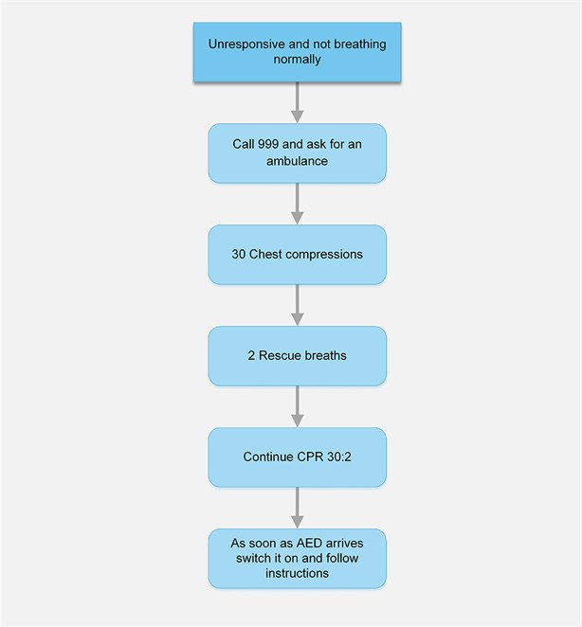
Appendix I
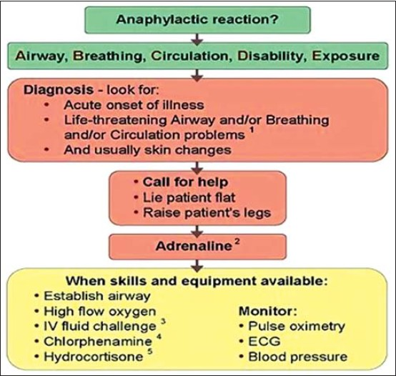
Adrenaline (epinephrine) intramuscularly (IM) in the anterolateral aspect of the middle third of the thigh (safe, easy, and effective):
- Adult IM dose 0.5 mg IM (=500 μg = 0.5 mL of 1:1000) adrenaline (epinephrine).
- >12 years: 500 μg IM (0.5 mL) that is, the same as the adult dose.
- 6-12 years: 300 μg IM (0.3 mL).
- <6 years: 150 μg IM (0.15 mL).

